**Data Communication Networks**

**Name: Sujal Khunt**

**Enrollment NO: 24FOTCA13902**

**STAR TOPOLOGY:**

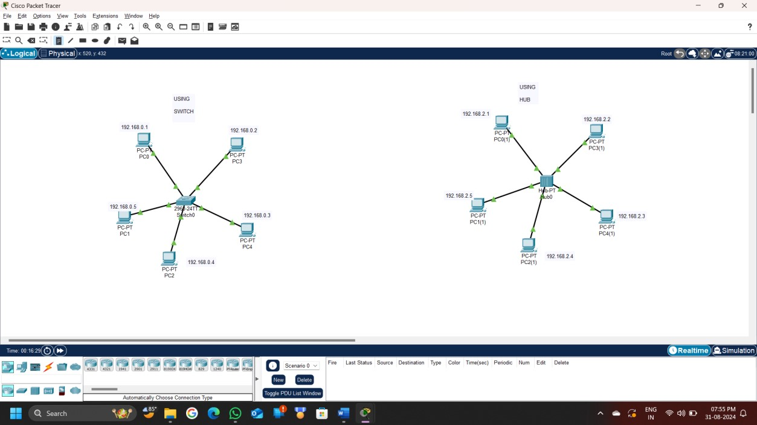

**STEPS:**

**USING SWITCH:**

1. Open Cisco Packet Tracer: Start a new project.
2. Add Devices: Place a switch in the center of the workspace and add several PCs around it.
3. Connect Devices: Use straight-through cables to connect each PC to the switch.
4. Configure IP Addresses: Assign unique IP addresses to each PC within the same subnet.
5. Verify Connectivity: Test the network by pinging from one PC to another.

**USING HUB:**

1. Open Cisco Packet Tracer: Start a new project.
2. Add Devices: Place a hub in the center of the workspace and add several PCs around it.
3. Connect Devices: Use straight-through cables to connect each PC to the switch.
4. Configure IP Addresses: Assign unique IP addresses to each PC within the same subnet.
5. Verify Connectivity: Test the network by pinging from one PC to another.

